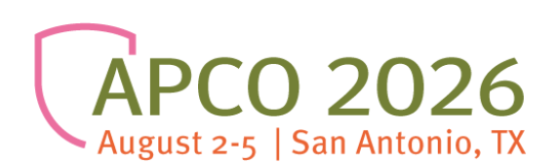

Letter of Request to Attend Conference

This is a suggested template for a letter you can draft to request employer support for your attendance to APCO 2026, August 2-5 in San Antonio, TX. If you decide to use it, please make sure you include your agency and supervisor’s name.

Dear [Supervisor’s name],

This is to request approval to attend APCO 2026, August 2-5, 2026, at the Henry B. Gonzalez Convention Center in San Antonio, TX. I believe that attending this conference will benefit me and our agency with the conference’s relevant educational sessions and networking opportunities with colleagues from across the nation. This event attracts 6,000+ like-minded leaders offering the best format for idea-exchange.

APCO provides enormous value for money. The early bird registration fee is $525.00 for APCO Members and $750.00 for Non-members. The fee covers all sessions offered at the Conference (up to 20 CEU credits)

The group rate lodging for this Conference ranges from $189- $239 + tax per night.

APCO promotes the Annual Conference as world-class education that is unparalleled in the public safety & emergency communications field. For the benefits that I expect to derive from this conference, I believe that the costs are reasonable and I hope you will support my attendance.

Sincerely,

[Your name]

